Date: Dec 21st 2022
Place: Orchard Industrial Estate,
Unit 18a & 18b,
Evesham Rd,
Cheltenham GL54 5EB
DECLARATION OF CONFORMITY

We, Puredrive Energy Limited, (hereafter referred to as “PDE” or “COMPANY”), as the manufacturer of ESS Inverters, hereby declare the cyber security assessments of our ESS Inverter are performed according to the ETSI EN 303 645 standard, and in accordance with the requirements of G99-1/8 (2021-09) & ENA EREC G G98 /1-6 (2021-09 standard Sections 9.1.7, 9.1.8 regarding “Cyber Security”.

- Products Information
Products Type | ESS Inverters
Model Names | PureInv 4K6HB, PureInv 3K6HB

- The ESS Inverters include a system of internal and external logic communications as summarized in the following scheme:
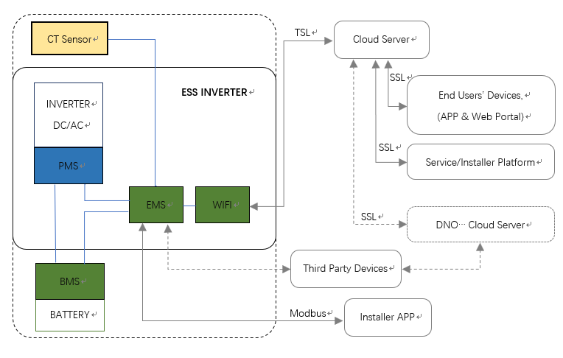
Where the main components involved and their main functions are explained in the following table:
Name | Meaning | Function | Location
PMS | Power Management System | Monitor and manage power fluxes through the inverter, execute EMS commands depending on grid parameters. | Inverter
BMS | Battery Management System | Monitor battery/cells status, execute PMS commands within safety conditions. | Battery
EMS | Energy Management System | Monitor all fields measures, calculate power and currents of every component of the system, receive external commands, transmit commands to PMS. | Inverter
CT Sensor | External Current Detection Device | Detect current from/flow to grid, send signal to EMS. | Accessory
WIFI | WIFI Communication Device | Transmit data to cloud server, receive commands from server. | Inverter

And the subjects/parties involved in communication with ESS Inverters are listed in the following table, together with purpose of the respective communications.
Subjects/Parties | Meaning and Devices | Operations
Installer APP | Mobile Devices (via APP) | Locally connect to ESS Inverter through fieldbus communication protocol (Modbus RTU) for monitoring and configuring inverter settings.
End Users | Mobile Devices (via APP), PC (via web portal) | Remotely monitor ESS Inverter working status, parameters, settings.
Service/Installer Platform | Mobile Devices (via APP), PC (via web portal) | Remotely monitor ESS Inverter working status, parameters, settings.  Remotely diagnose, configure, upgrade ESS Inverters.
DNO, Energy Community Management | Proprietary ITC Infrastructure, Possible Proprietary Field Device | Remotely monitor instantaneous and historical data via API, send set-points for grid services.

- All communications between internal components of ESS Inverter, and between EMS and supplied external CT Sensor and compatible battery (BMS), take place via serial lines (CANBUS, RS485), which are not directly connect to outside.

- The communication port between the ESS Inverter and the outside is constituted by the logic port (DB9) on the machine; the communication between ESS Inverter and the outside world can take place via a WIFI Communication Device supplied by the COMPANY.

- The direct recipients/senders of communications with the ESS Inverter are:
- In all cases the Could Server applicated – the communication is made secure by the use of TSL (Transport Layer Security) technology on our WIFI Communication Device and Cloud Server, and by the use of SSL (Secure Sockets Layer) technology on End Users’ device side and Service/Installer Platform side;
- Possible third party (such as DNO…) field device – the cyber security of the communication between ESS Inverter and third-party device will be ensured by the use of an appropriate technology (SSL or TSL typically) agreed between our company and the third party on case-by-case basis, the cyber-security between third-party device and third-party server/cloud will be the responsibility of the third party itself.

- All communications between Cloud Server and the subjects/parties are cyber-protected by SSL technology.

